Name\_\_\_\_\_\_\_\_\_\_\_\_\_\_\_\_\_\_\_\_\_\_\_\_\_\_\_\_\_\_\_\_\_\_\_\_\_\_\_\_\_\_Date\_\_\_\_\_\_\_\_\_\_\_\_\_\_\_\_\_\_\_\_\_\_\_\_\_\_Period\_\_\_\_\_\_

***ACE 3- Decimal Ops***

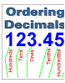

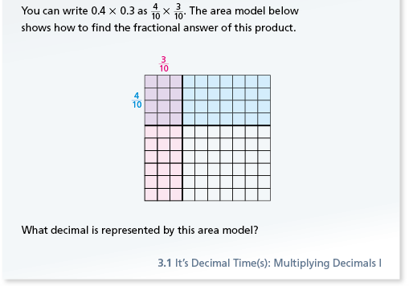

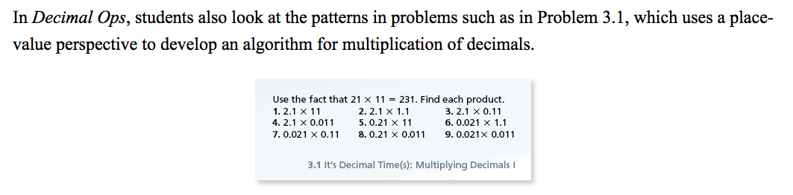



ACE_dots

Applications | Connections | Extensions

**A C E**

Applications

**1.** For each decimal multiplication problem below,

**•** Write each decimal factor as an equivalent fraction.

**•**Find the product of the two fractions.

**•**Write the product in equivalent decimal form.

**a.** 0.3 × 1.4 **b.** 1.2 × 3.54

3 x 14 = 42

10 10 100

decimal form = 0.42

**c.** 1.04 × 0.6 **d.** 23.2 × 0.45

**e.** 0.54 × 1.2 **f.** 4.20 × 5.6

**2.** Use the fact that 17 × 13 = 221 to find each product.

**a.** 1.7 × 13 **b.** 0.17 × 1.3 **c** 17 × 0.13

**For Exercises 3–6, use the given information to find each product.**

**3.** If 34 × 8 = 272, what is 3.4 × 0.8? What is 0.34 × 0.08?

**4.** If 32 × 517 = 16,544, what is 3.2 × 5.17?

**5.** If 7263 × 32 = 232,416, what is 7.263 × 3.2?

**6.** If 2405 × 5317 = 12,787,385, what is 2.405 × 53.17?

**7. Multiple Choice** Which product is greater than 1?

**A.** 2.4 × 0.75 **B.** 0.66 × 0.7

**C.** 9.8 × 0.001 **D.** 0.004 × 0.8

**8. Multiple Choice** Which product is greatest?

**F.** 0.6 × 0.4 **G.** 0.06 × 0.04

**H.** 0.06 × 0.4 **J.** 0.6 × 0.04

**9.** Show how to calculate each of these products using a multiplication algorithm for whole numbers. Estimate each product to check your answer.

**a.** 325 × 24 **b.** 580 × 73

**c.** 5.84 × 73 **d.** 3.17 × 2.8

**e.** 29 × 732 **f.** 2.9 × 7.32

**For Exercises 10–13, identify the errors in each calculation and find the correct product.**

**10. 11.**

327

× 123

981

654

+ 327

1962

472

× 19

4248

+ 472

4720

**12. 13.**

571

× 342

2

2800

+150000

152802

47.2

× 1.9

4248

+ 4720

896.8

**For Exercises 14–19, estimate each product. Then compute the exact result without using a calculator.**

**14.** 0.6 × 0.8 **15.** 2.1 × 1.45

**16.** 3.822 × 5.2 **17.** 0.9 × 1.305

**18.** 5.13 × 2.9 **19.** 4.17 × 6.72

**21.** Sweety’s Ice Cream Shop sells ice cream by weight. They charge

$6.95 per pound. If your dish of ice cream weighs 0.42 pounds, how

much will it cost?

**22.** Aaron plans to buy new flooring for his office. His office floor is a rectangle that is 7.9 meters by 6.2 meters.

**a.** How many square meters of floor space does his office have?

**b.** Suppose flooring costs $5.90 per square meter. How much will  
 the new flooring for Aaron’s office cost?

**23.** Ten-year-old Chi learned a lot of math from his older brother,

Shing. One day, Shing told him that when you multiply a

number by 10, “you just add a zero.”

1. With Shing’s idea in his mind, Chi says, “To find 10 × 20, I just  
   add a zero. So, 20 + 0 = 20.” How would you correct him?
2. After Chi realizes that “adding zero” actually means “putting an

extra zero at the end,” he says,

“10 × 0.02 equals 0.020 by putting an extra zero at the end.” Is he right this time? How would you rephrase “putting an extra zero at the end” in case the other number is a decimal number?  
Explain why your suggestion works.

**c.** How can you find the result of multiplying by 100; 1,000; or 10,000

using a similar strategy?

**24.** For each decimal division problem below,

**•** Write the dividend and divisor as fractions with common  
 denominators.

**•** Estimate the quotient of the two fractions.

**•** Find the exact value of the quotient.

**a.** 4.2 ÷ 2.1 **b.** 16.1 ÷ 2.3

4 2/10 ÷ 2 1/10

42/10 ÷ 21/10

42 ÷ 21 = 2

**c.** 0.56 ÷ 0.08 **d.** 7.6 ÷ 0.04

**e.** 25.9 ÷ 1.85  **f.** 36 ÷ 2.4

**25.** Write these decimal divisions as equivalent whole-number

divisions. Then find the quotients.

**a. b. **

44.8 ÷ 3.2 =

(44.8 \*10)÷(3.2 \* 10) =

448 ÷ 32 =

\_\_\_**1**\_**4**\_\_

32] 4 4 8

-3 2 ⬇

1 2 8

- 1 2 8

0

**c.  d. **

**28.** Here are three decimal divisions that are closely related. Do

they all have the same result? Why or why not?

**a.** 27.5 ÷ 55 **b.** 2,750 ÷ 5.5 **c.** 0.275 ÷ 0.55

**30.** Find the value of *N* that makes each equation true.

**a.** 3.2 × *N* = 0.96 **b.** 0.7 × *N* = 0.042 **c.** *N* × 3.21 = 9.63

**d.** *N* ÷ 0.8 = 3.5 **e.** 2.75 ÷ *N* = 5.5

**f.** 5.3*N* + 7.25 = 70.85

**31.** Find each quotient.

**a.  b.  c.**

**For Exercises 32–39, use long division to find each quotient.**

**32.** 43 ÷ 8.6 **33.** 418.6 ÷ 80.5

**34.** 254 ÷ 40 **37.** 45.13 ÷ 0.125

**38.** 1.2 ÷ 4.8  **39.** 1.99 ÷ 10

**41.** Sandy cuts lawns in her neighborhood during the summer. When

Sandy bought 4.5 gallons of gasoline for the mower, the pump showed

a charge of $18. What was the gasoline price in dollars per gallon?

**42.** Garden plots in the Portland Community Garden are rectangles

limited to 45 square meters. Christopher and his friends want a plot

that has a width of 7.5 meters. What length will give a plot that has  
 the maximum area allowed?

**46.** Loren is putting brick along both edges of the 21-meter walkway to

his house. Each brick is 0.26 meters long. Loren is placing the bricks

end to end.

1. How many bricks does he need?

**b.** If bricks cost $.15 apiece, how much will the brick border cost?

**47.** Angie is making wreaths to sell at a craft show. She has 6.5 yards of

ribbon. Each wreath has a bow made from  yards of ribbon. How

many bows can she make?

**54.** Copy the table below, and write each fraction as a decimal.

|  |  |
| --- | --- |
| **Fraction** | **Decimal** |
|  |  |
|  |  |
|  |  |
|  |  |
|  |  |
|  |  |
|  |  |
|  |  |

1. Describe the pattern you see in the table.

**b.** Use the pattern to write a decimal representation for each fraction. Use your calculator to check your answers.

**i.**  **ii.  iii. **

**c**.What fraction is equivalent to each decimal? Note that 1.222... can be written as 1 + 0.222...

**i.** 1.2222… **ii.** 2.7777…

**55.** For parts (a)–(d), copy the number line and label each tick mark.

55a copy**a.**

55b copy**b.**

55c copy**c.**

5d copy**d.**

**e.** Explain your strategy for answering parts (a)–(d).