Name___________________________________________________Date___________________Period______

**ACE investigation 2**

**Variables and Patterns**



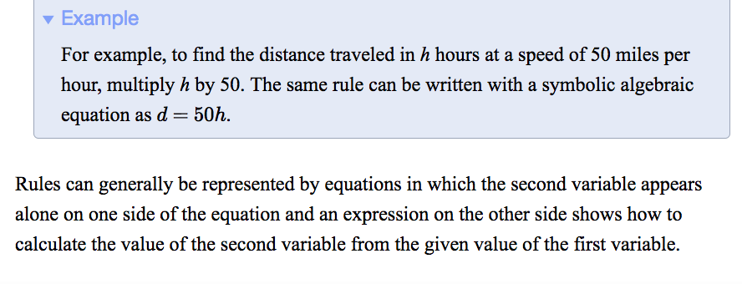

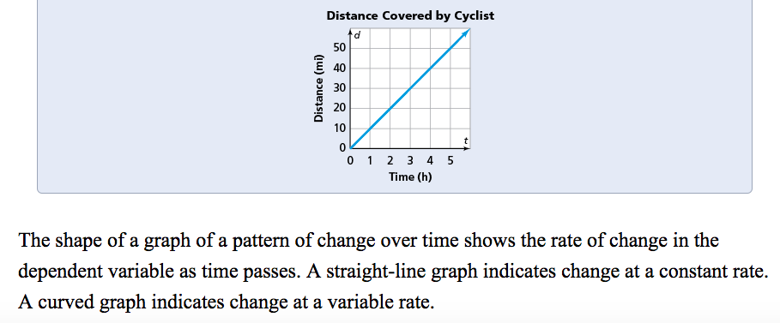

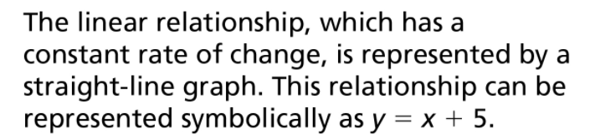

1. The following table shows typical weights for young tiger cubs from birth to 11 weeks. Use the data to answer parts (a)–(g).

|  |  |
| --- | --- |
| **Age (weeks)** | **Expected Body Weight (kg)** |
| birth | 1.3 |
| 1 | 2.3 |
| 2 | 3.0 |
| 3 | 3.8 |
| 4 | 4.5 |
| 5 | 5.2 |
| 6 | 6.0 |
| 7 | 6.7 |
| 8 | 7.5 |
| 9 | 7.6 |
| 10 | 8.9 |
| 11 | 9.7 |

**Typical Weights for Tiger Cubs**

1. What weight is predicted for a 1-week-old tiger cub?
2. What weight is predicted for a 10-week-old tiger cub?
3. At what age do tiger cubs typically weigh 7 kilograms?
4. Plot the (*age, weight*) data on a coordinate grid with appropriate

scales. Explain why it does or does not make sense to connect the  
points on that graph.



0 1 2 3 4 5 6 7 8 9 10 11 12

Age in Weeks

**e.** How would you describe the pattern relating tiger cub age

and weight?

1. How is the pattern shown in the data table?

**g.** How is the pattern shown in the coordinate graph?

Untitled-1 copy**2.** Desi is planning a go-kart party. Kartland gives him a  
table of group rates. Thunder Alley gives him a graph.  
The table and graph are shown below.

**Kartland Price Packages**

|  |  |  |  |  |  |  |
| --- | --- | --- | --- | --- | --- | --- |
| **Number of Laps Raced** | 10 | 20 | 30 | 40 | 50 | 60 |
| **Cost** | $25 | $45 | $65 | $85 | $105 | $125 |

1. 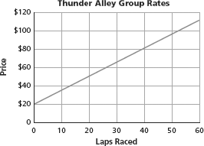Find the cost at  
   both locations for  
   50 laps.
2. Find the cost at  
   both locations for  
   20 laps.
3. Find the cost both locations for 35 laps.
4. Look for patterns in the relationships between number of laps and cost at Thunder Alley. How is the pattern shown in the table?
5. Look for patterns in the relationships between number of laps and cost at Kartland. How is the pattern shown in the graph?
6. The following table shows the fees charged for campsites at one of the campgrounds on the Ocean Bike Tours route.

**Campground Fees**

|  |  |  |  |  |  |  |  |  |
| --- | --- | --- | --- | --- | --- | --- | --- | --- |
| **Number of Campsites** | 1 | 2 | 3 | 4 | 5 | 6 | 7 | 8 |
| **Total Fee** | $12.50 | $25.00 | $37.50 | $50.00 | $62.50 | $75.00 | $87.50 | $100.00 |

1. Examine a coordinate graph of the data.

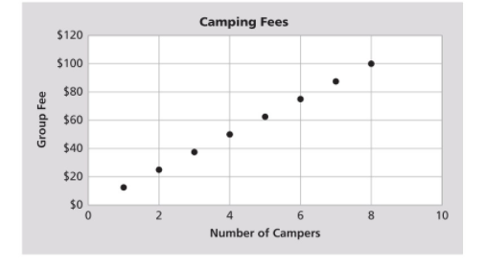

1. Does it make sense to connect the points on the graph? Explain.
2. Using the table, describe the pattern of change in the total campground fee as the number of campsites increases.
3. How is the pattern you described in part (c) shown in your graph?

**4.** Some class officers want to sell T-shirts to raise funds for a class trip. They ask the students in their class how much they would pay for a shirt and recorded the data in a table.

**Projected Shirt Sales**

|  |  |  |  |  |  |
| --- | --- | --- | --- | --- | --- |
| **Price per Shirt** | $5 | $10 | $15 | $20 | $25 |
| **Number of Shirt Sales** | 50 | 40 | 30 | 20 | 10 |

1. Describe the relationship between the price per shirt and the expected number of shirt sales. Is this the sort of pattern you would expect?

**b.** Copy and complete this table to show the relationship between price per shirt and the expected total value of the shirt sales.

**Projected Shirt Sales**

|  |  |  |  |  |  |
| --- | --- | --- | --- | --- | --- |
| **Price per Shirt** | $5 | $10 | $15 | $20 | $25 |
| **Number of Shirt Sales** | 50 | 40 | 30 | 20 | 10 |
| **Value of Shirt Sales** | $250 | $400 | Gray Box | Gray Box | Gray Box |

**c.** How would you describe the relationship between price per shirt and expected total value of shirt sales? Is this the sort of pattern you would expect?

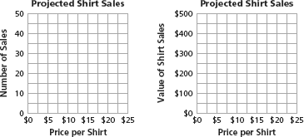d. Make coordinate graphs of the data like the ones started below.

**e.** Explain how your answers to parts (a) and (c) are shown in the graphs.

1. A camping-supply store rents camping gear for $25 per person

for a week.

1. Examine a table of the total rental charges for 0, 5, 10, . . . ,40 campers.

Macintosh HD:Users:cdiamond:Desktop:Screen Shot 2017-02-20 at 12.59.56 AM.png

1. Examine a coordinate graph using the data from the table.

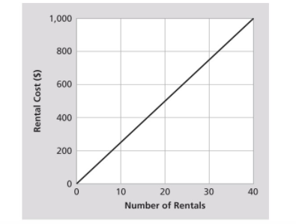

1. Compare the pattern in your table and graph with patterns you found in the campground fee data in Exercise 3. Describe the similarities and differences between the two sets of data.

**6.** The bike tour partners need to rent a truck to transport camping gear, clothes, and bicycle repair equipment. They check prices at two truck-rental companies.

**a.** East Coast Trucks charges $4 for each mile driven. Examine the table of the charges for 0, 100, 200, . . . , 800 miles.

Macintosh HD:Users:cdiamond:Desktop:Screen Shot 2017-02-20 at 12.59.56 AM.png

1. Philadelphia Truck Rental charges $40 per day and an additional $3.00 for each mile driven. Examine the table of the charges for renting .a truck for five days and driving it 0, 100, 200, . . . , 800 miles.

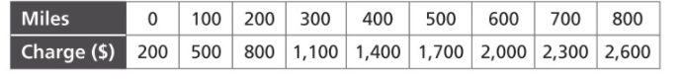

1. On one coordinate graph, the charges for both rental  
   companies are plotted. Use different colors to mark points representing the two companies’ plans.

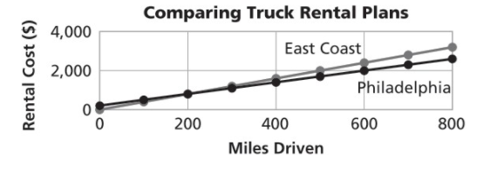

**d.** Based on your examination of parts (a)–(c), which company offers the better deal? Explain.

**7.** The table below shows fees for using a campsite at a state park for 1 day up to the park limit of 10 days.

**Campsite Fees**

|  |  |  |  |  |  |  |  |  |  |  |
| --- | --- | --- | --- | --- | --- | --- | --- | --- | --- | --- |
| **Days of Use** | 1 | 2 | 3 | 4 | 5 | 6 | 7 | 8 | 9 | 10 |
| **Total Fee** | $20 | $30 | $40 | $50 | $60 | $70 | $75 | $80 | $85 | $90 |

1. Examine a coordinate graph representing data in the table.

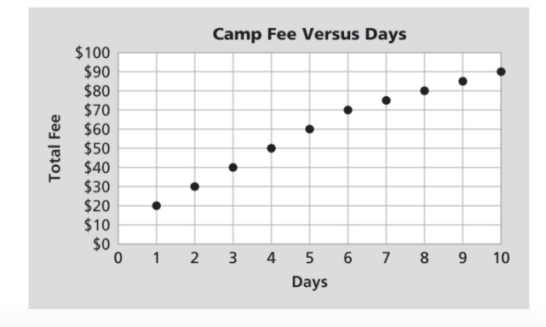

1. Does it make sense to connect the points on your graph? Explain.
2. Describe the pattern relating the variables *days of use* and *campsite fee.*

**9.** Coordinate graphs with four quadrants can also be used for locating places on a map. The four boxes in the table below show where in the four quadrants the *x*- and *y*-values will be positive and negative.

|  |  |
| --- | --- |
| ( – , + ) | ( + , + ) |
| ( – , – ) | ( + , – ) |

Use the table and the map grid to give coordinates locating each labeled site. Write the coordinates as (*x*, *y*).

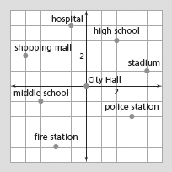

1. City Hall
2. hospital
3. stadium
4. police station
5. fire station f. middle school

g. high school **h.** shopping mall

**Suppose a motion detector tracks the time and the distance traveled as you walk 40 feet in 8 seconds. The results are shown in the graphs below. Use them to answer Exercise 10.**

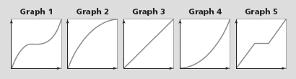

**10.** Match one of the (*time, distance*) graphs above with the story that describes each walk.

1. You walk at a steady pace of 5 feet per second.
2. You walk slowly at first, and then steadily increase your  
   walking speed.
3. You walk rapidly at first, pause for several seconds, and then walk at an increasing rate for the rest of the trip.
4. You walk at a steady rate for 3 seconds, pause for 2 seconds, and then walk at a steady rate for the rest of the trip.

**e.** You walk rapidly at first, but gradually slow down as you reach the end of the walk.

**12.** The graphs below show five patterns for the daily sales of a new video game as time passed after its release. Match each (*time, sales*) graph with the “story” it tells.

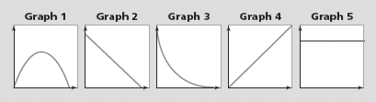

1. The daily sales declined at a steady rate.
2. The daily sales did not change.
3. The daily sales rose rapidly, then leveled off, and then  
   declined rapidly.
4. The daily sales rose at a steady rate.

**e.** The daily sales dropped rapidly at first and then at a slower rate.

**13. Multiple Choice** Jamie is going to Washington, D.C., to march in a parade with his school band. He plans to set aside $25 at the end of each month to use for the trip. Choose the graph that shows how Jamie’s savings will grow as time passes.

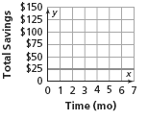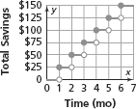**A.**  **B.**

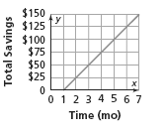**C.**  **D.** None of these is correct.

**14.** The graph below shows how the temperature changed during an all-day hike by students in the Terrapin Middle School science club.

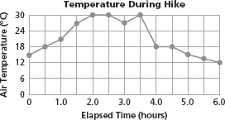

1. What was the maximum temperature and when did it occur?

**b.** When was the temperature rising most rapidly?

**c.**When was the temperature falling most rapidly?

**d**. When was the temperature about 24°C?

**e.** The hikers encountered a thunderstorm with rain. When do you think this happened?

**Jacy works at a department store on the weekends. The graph at the right shows parking costs at the garage Jacy uses.**

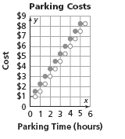**15. Multiple Choice** How much will Jacy spend to park  
for less than half an hour?

**F.** $0.50

**G.** $0.75

**H.** $1.00

**J.** $1.50

**16. Multiple Choice** How much will Jacy spend to park  
for 4 hours and 15 minutes?

**A.** $6.00

**B.** $6.50

**C.** $6.75

**D.** $7.00