Name\_\_\_\_\_\_\_\_\_\_\_\_\_\_\_\_\_\_\_\_\_\_\_\_\_\_\_\_\_\_\_\_\_\_\_\_\_\_\_\_\_Date\_\_\_\_\_\_\_\_\_\_\_\_\_\_\_\_\_\_\_\_\_\_\_\_\_\_\_\_\_\_Period\_\_\_\_\_\_

***ACE investigation 1***

**Variables and Patterns**





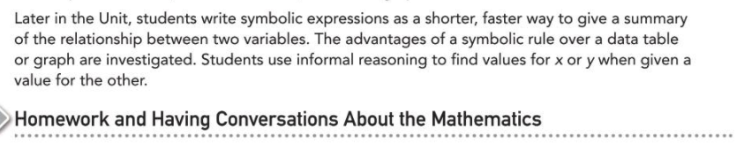



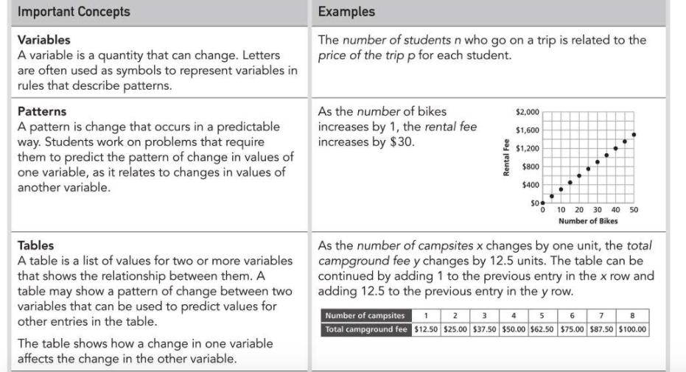

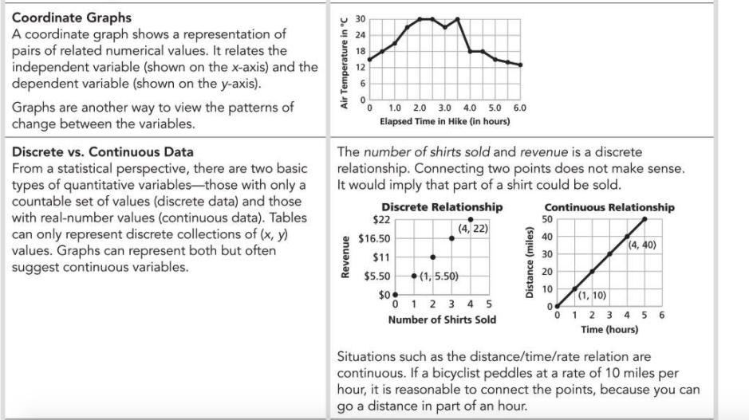

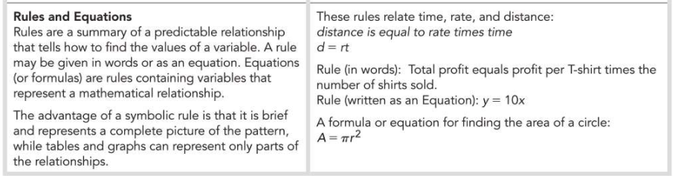

***ACE*** : Applications/Connections/ Extensions

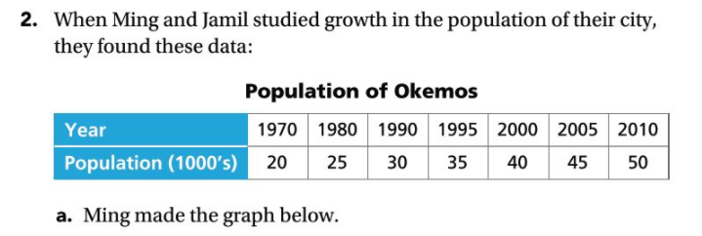

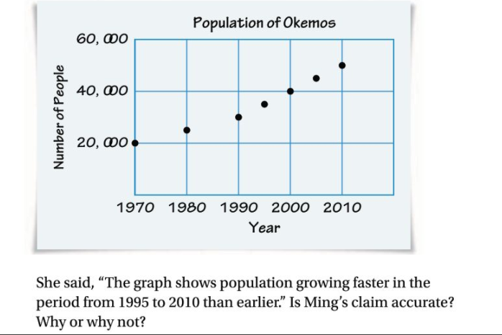

b. Jamil made a different graph it is shown below.

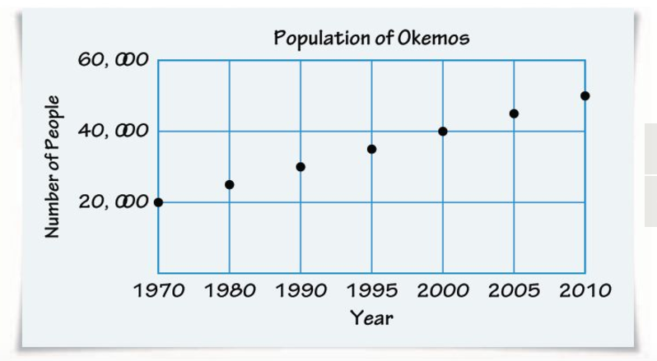

Jamil said, “The graph shows population growing at a steady rate.” Is his claim accurate? Why or why not?

3. The graph below shows the numbers of cans of juice

purchased each hour from a school’s vending machines in one

day. On the x-axis of the graph, 7 means the time from 7:00 to

8:00, and so on.

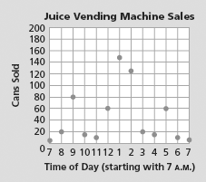

1. What might explain the high and low sale time periods shown by the graph?
2. Does it make sense to connect the points on this graph? Why or why not?

4. Before deciding that bike tour customers could ride 60-90

miles each day, Ocean Bike Tours partners went on a test

ride. The (time, distance) data for their ride are shown in the

table below.

**Ocean Bike Tours Test Ride**

|  |  |  |  |  |  |  |  |  |  |  |  |  |
| --- | --- | --- | --- | --- | --- | --- | --- | --- | --- | --- | --- | --- |
| **Time (h)** | 0 | 0.5 | 1.0 | 1.5 | 2.0 | 2.5 | 3.0 | 3.5 | 4.0 | 5.0 | 5.5 | 6.0 |
| **Distance (mi)** | 0 | 10 | 19 | 27 | 34 | 39 | 36 | 43 | 53 | 62 | 66 | 72 |

1. Plot these data on a coordinate graph with scales and labels



1. At what time(s) in the ride were the four business partners riding fastest?

How is that information shown in the table and on the graph?

1. At what time(s) in the ride were they riding slowest?

How is that information shown in the table and on the graph?

1. How would you describe the overall pattern in cyclist speed throughout the test run?
2. What might explain the dip in the distance data between 2.5 and 3.5 hours

**5.** Students have a test to see how many sit-ups they can complete in 10 minutes. Andrea and Ken plot their results. Their graphs are shown below.

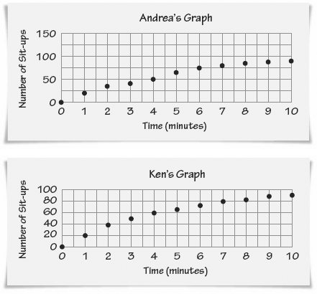

1. Ken claims that he did better because the points on his

graph are higher than the points on Andrea’s graph. Is Ken correct ? Explain.

1. In what ways do the results of the sit-up test show a

pattern of endurance in physical activity that is similar to the results of the test ride by the Ocean Bike Tours partners?

1. Which person had the greatest average number of sit-

ups per minute?

1. Compare Ken’s pace in the first two minutes to his

pace in the last two minutes.

**6.** Katrina’s parents kept a record of her growth in height from

birth until her 18th birthday. Their data is shown in the

table below.

**Katrina’s Height**

|  |  |
| --- | --- |
| **Age (yr)** | **Height (in.)** |
| birth | 20 |
| 1 | 29 |
| 2 | 33.5 |
| 3 | 37 |
| 4 | 39.5 |
| 5 | 42 |
| 6 | 45.5 |
| 7 | 47 |
| 8 | 49 |
| 9 | 52 |
| 10 | 54 |
| 11 | 56.5 |
| 12 | 59 |
| 13 | 61 |
| 14 | 64 |
| 15 | 64 |
| 16 | 64 |
| 17 | 64.5 |
| 18 | 64.5 |

1. Use the grid below to make a coordinate graph of Katrina’s height data.



1. During which time interval(s) did Katrina have

her greatest “growth spurt”?

1. During which time interval(s) did Katrina’s height change

the least?

1. Would it make sense to connect the points on the graph? Why or why not?

**e.** Is it easier to use the table or the graph to answer

parts (b) and (c)? Explain.

**8.** Three students made graphs of the population of a town

called Huntsville. The break in the *y*-axis in Graphs A and C

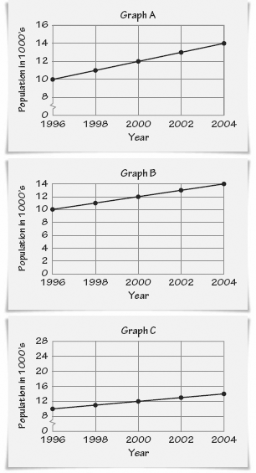 indicates that there are values missing between 0 and 8.

**a.** Describe the relationship between time and population as shown in

each of the graphs.

**b.** Is it possible that all three graphs correctly represent the  
 population growth in Huntsville? Explain.

**11.** Amanda made the graphs below to show how her level of hunger and  
her happiness changed over the course of a day. She forgot to label  
the graphs.

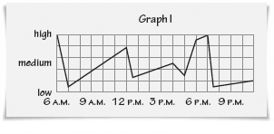

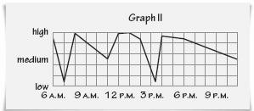

Use the following descriptions to determine which graph shows Amanda’s hunger pattern and which graph shows Amanda’s happiness. Explain.

****

**12.** Celia uses (*time, distance*) data from one part of the bike

tour test run to draw the following graph relating time and

speed. Celia forgot to include scales on the axes of the

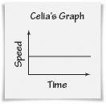 graph.

1. What does this graph show?
2. Is the graph most likely a picture of speed for a cyclist, the tour van, or the wind over a part of one day’s trip?

Explain your reasoning about each possibility.

**13.** The following table shows (*time, distance*) data from the bike tour group’s van ride home from Williamsburg to Atlantic City.

**Williamsburg to Atlantic City Van Ride**

|  |  |  |  |  |  |  |  |  |  |
| --- | --- | --- | --- | --- | --- | --- | --- | --- | --- |
| **Time (h)** | 0 | 1 | 2 | 3 | 4 | 5 | 6 | 7 | 8 |
| **Distance (mi)** | 0 | 50 | 110 | 150 | 200 | 220 | 280 | 315 | 345 |

1. What was their average speed for the whole trip?

**b.** What was their average speed for the first four hours of the trip?

**c.** What was their average speed for the second four hours of the trip?

Connections

ACE_dots

**14.** Consider the pattern below.

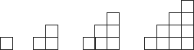

1. Draw the next shape in the geometric pattern.
2. Make a table of (*number of squares in bottom row, total number of squares*) data for the first ten shapes in the pattern.

**c.** Describe the pattern of increase in total number of squares as length of the bottom row increases.

Extensions

ACE_dots

**23. a.** A school club sells sweatshirts to raise money. Which, if any, of the graphs below describes the relationship you would expect between the price charged for each sweatshirt and the profit?

Explain your choice, or draw a new graph that you think better describes this relationship.

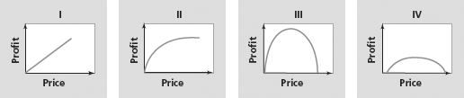

**b.** What variables might affect the club’s profits?