Name\_\_\_\_\_\_\_\_\_\_\_\_\_\_\_\_\_\_\_\_\_\_\_\_\_\_\_Date\_\_\_\_\_\_\_\_\_\_Period\_\_\_

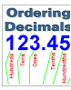

**DECIMAL OPS -** INVESTIGATION 1

***ACE***

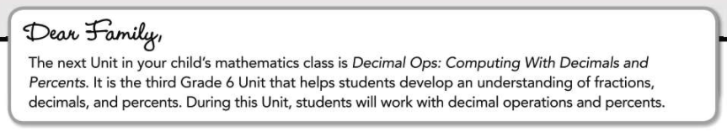

***Unit Goals***

***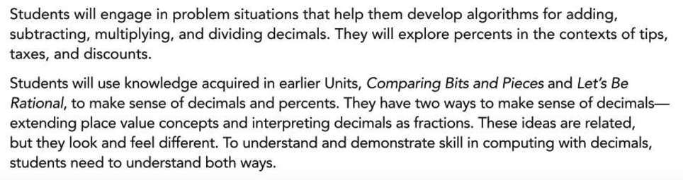***

***Helping Your Child***

***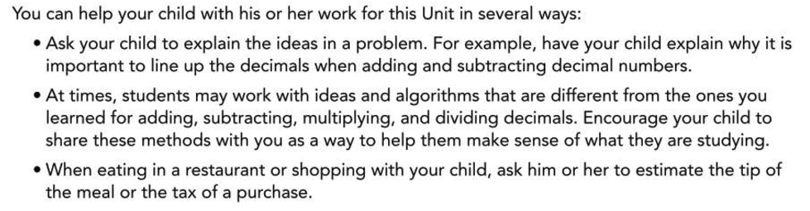***

***Contents of this Packet***

1. A few important mathematical ideas that your child will learn in **Decimal Ops** are given on the next page.
2. Teacher selected ACE (**A**pplication, **C**onnection, and **E**xtension) practice problems are available for students to show their work.
3. These and additional problems are available in the Connected Math textbook as well.

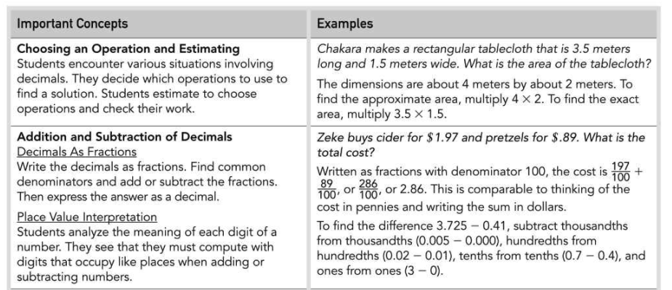 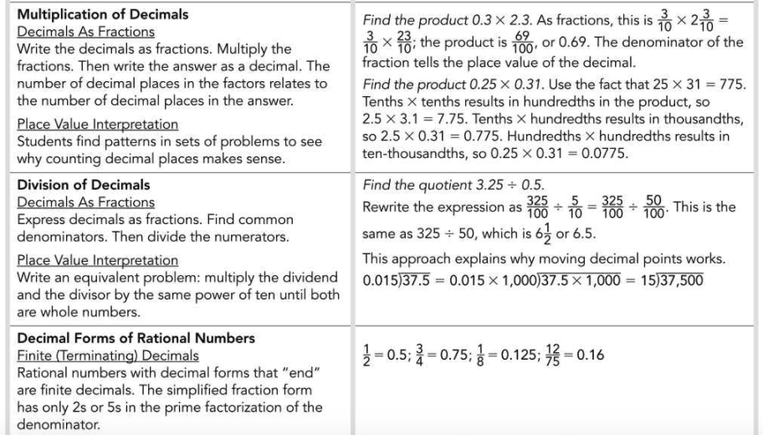

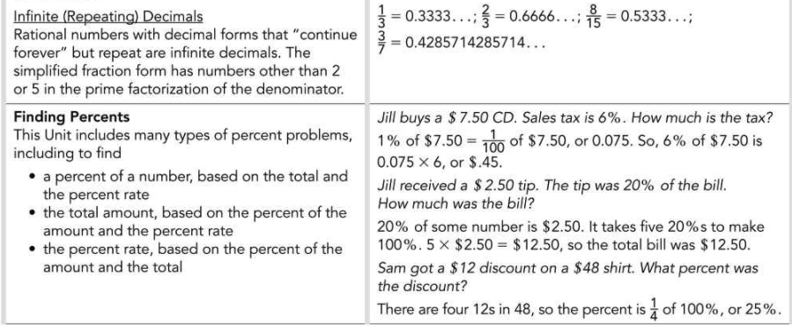



ACE_dots

Applications | Connections | Extensions

**A C E**

Applications

**For Exercises 1–7,**

• **Write a number sentence for the problem.**

• **Estimate the answer.**

• **Use mental arithmetic, a calculator, or some other method to find**

**the exact answer.**

• **Explain how your estimate helps you check the exact answer.**

1. Billie buys materials for a project at a fabric store. She has $16.95 to spend. She buys fabric for $8.69, craft glue for $1.95, and craft paper for $4.29. How much money does she have left after she pays for the items?

**2.**

Greg’s home is 1.8 miles from his school. There is a music

store halfway between school and his home. Today, Greg wants to stop at the store after school. Right now, he is 0.36 miles away from school.

**a.** How far is the music store from Greg’s school?

**b.** How much farther does Greg need to walk to get to the store?

**c.** How many miles does he have left to walk home?

**3.** A local farm grows strawberries, blueberries, and raspberries. Customers can pick their own fruit at the farm for $2.95 per pound.

**a.** The Payne family picks 10.5 pounds of raspberries. How much do they have to pay?

**b.** A week later, the Paynes pick 6.75 pounds of blueberries and 5.2 pounds of strawberries. How much do they have to pay?

**4.** The drink dispenser in a fast-food restaurant holds 250 liters of lemonade. How many 0.6-liter drinks can be dispensed before a refill is needed?

**To make estimation with decimals easier, you can think about whole numbers or fractions that are close to the decimals in value. For Exercises 8–17, identify a common fraction that is equal to or close to each decimal.**

**8.** 0.2 **9.** 0.25

**10.** 0.4 **11.** 0.5

**12.** 0.6 **13.** 0.67

**14.** 0.8 **15.** 0.875

**16.** 0.9 **17.** 0.78

**For Exercises 18–23, write a whole number, mixed number, or fraction that could replace each decimal in an estimation task.**

**18.** 3.14 **19.** 12.96

**20.** 0.42 **21.** 473.2

**22.** 0.33 **23.** 4.25

**24.** On a cross-country trip, the Anderson family planned to average 500 miles and 10 hours of driving each day.

**a.** On average, how many miles per hour did the Andersons plan to drive?

**b.** At the rate from part (a), how far would the Andersons travel if they drove for 8 hours? For 12 hours?

**c.** How long would it take the Andersons to drive 450 miles at the rate from part (a)?

**25.** Elliot buys a 5-pound package of ground beef for $12.50.

**a.** What is the unit price of the ground beef?

**b.** At the same unit price, how much would 8 pounds of ground beef cost?

**c.** Varna buys a package of ground beef for $7.50 at the same unit price. What is the weight of the package?

**26.** Suppose 50 members of the sixth-grade class raise a total of

$740 during a poster sale.

**a.** What unit rate best describes this result?

**b.** There are 60 students in the seventh-grade class. The

seventh graders match the sixth graders’ fundraising

rate by selling t-shirts. How much money does the

seventh-grade class raise?

**27.**Draymond and his siblings ordered a pizza for $13.95 and

three drinks for $2.25 each. After lunch, they bought ice

cream cones for $2.75 each. Draymond calculated the total

cost of the meal.

**113.95 + 3(2.25) + 3(2.75) =**

**13.95 + 3(5.00) = 13.95 + 15**

**= 28.95**

1. Describe how Draymond’s calculations differ from the standard Order of Operations.

**b.** Why did Draymond still find the correct total?

**32. Multiple Choice** Which of these numbers is greatest? Explain how you know.

**A.** 81.9 **B.** 81.90 **C.** 81.900 **D.** 81.91

**33. Multiple Choice** Which group of decimals is ordered from least  
to greatest?

**F.** 5.6, 5.9, 5.09, 5.96, 5.139

**G.** 0.112, 1.012, 1.3, 1.0099, 10.12

**H.** 2.8, 2.109, 2.72, 2.1, 2.719

**J.** 0.132, 0.23, 0.383, 0.3905, 0.392

**34.** Match each number with a point on the number line below.

0.5 3.05 0.350 3.50 1.95 1.095

34 copy

**61.** You can add 13 meters 47 centimeters to 4 meters 72 centimeters by using decimal numbers. Since 13.47 + 4.72 = 18.19, the total length  
is 18 meters 19 centimeters.

Can you add 3 feet 7 inches and 5 feet 6 inches by using decimal numbers (3.7 + 5.6)? Explain your reasoning.

**62.** Mark says that 3.002 must be less than 3.0019 since 2 is less than 19. Explain why he is wrong.