Name__________________________________________Date__________________________Period______

***ACE 4 - Decimal Ops***

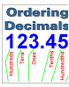



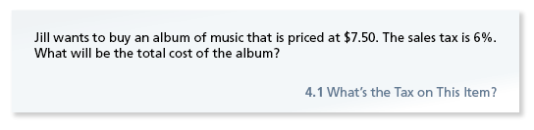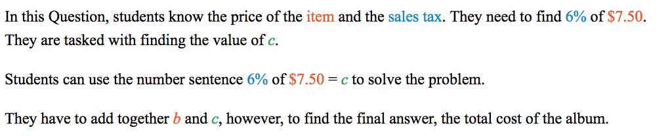

------------------------------------------------------------------------------------------------------------



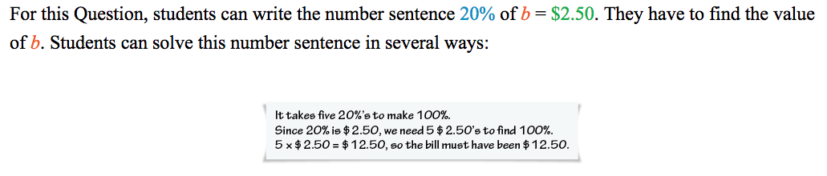

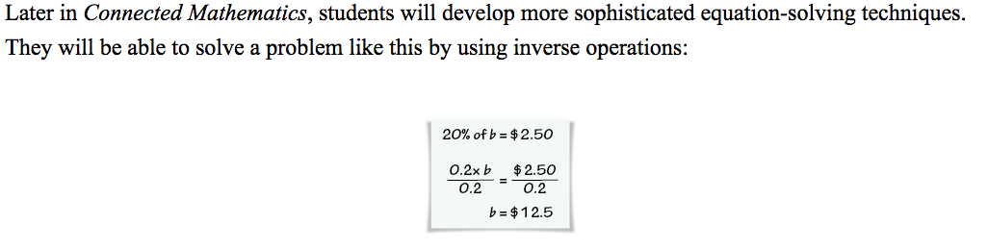



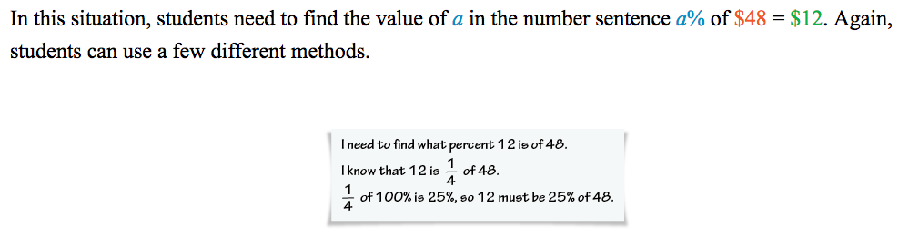

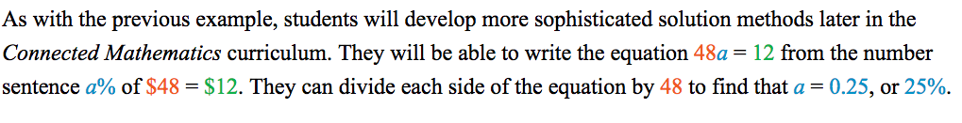

A C E

Applications | Connections | Extensions

**2.** Hot dogs at a carnival cost $2.99 each plus 7% tax. What is the

total cost for one hot dog?

**3.** A class conducts a survey of 1,000 students.

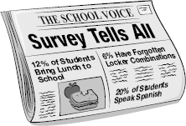

1. The survey reveals that 20% of the students speak Spanish. How

many students speak Spanish?

**b.** At one time or another, 6% of the students have forgotten their  
 locker combinations. How many students have forgotten their  
 locker combinations?

1. Of the Grade 6 students surveyed, 12% bring their lunch to

school. Suppose 24 sixth graders do this. How many Grade 6  
 students are at the school?

**4.** Arif and Keisha go to a restaurant for dinner. Their meals total $13.75.

The tax is 5%.

**a.** How much tax is added to the bill?

1. Arif and Keisha want to leave a 15% tip based on the bill and the tax combined. How much should they leave? Explain.

**c.** Arif ordered a more expensive meal than Keisha. After the tax and tip were figured, he decided he should pay $3.00 more than Keisha. How much should each pay?

**5.** Jen and Sarah go to lunch at the Green Grill. Their meals total $28.00.

The tax is 6%.

**a.** What is the total cost including tax?

**b.** Jen and Sarah want to leave a 20% tip based on the cost before tax. How much tip should they leave?

**c.** Describe two strategies that Jen and Sarah can use to figure the amount of the tip.

**6.** Marilyn carries a tip-calculator card with her. It lists the amounts for 15% and 20% tips on whole-dollar values up to $100.00. Her daughter notices a pattern. She says, “For each dollar the cost increases, the tips in the 15% column increase by $.15.”

**a.** Explain why this pattern occurs for 15,-tip values.

b. For each dollar increase, what is the amount of increase in the

20% column?

**c .**The tip-calculator card only goes up to $100.00. How can you use

the card if your restaurant bill totals $325.00?

**8.** The Science Supply Store is having a sale. All graduated cylinders

are 25% off. Mrs. Delmar buys four graduated cylinders that were originally $8.00 each and six that were originally $9.50 each.

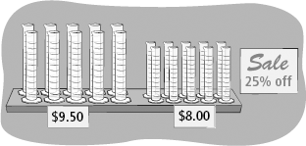

1. How much money will Mrs. Delmar save?
2. What percent of the original price will Mrs. Delmar pay?

**c.** Suppose the sales tax is 4%. What is Mrs. Delmar’s total cost?

**The questions in Exercises 9–11 involve discounts at a store that is having a hat sale. All regular-priced hats are 20**% **off. Shirley, Lisa, and Sandy each find a hat to buy.**

**9.** Shirley’s beach hat was originally $24.95. What is the sale price?

**10.** Sandy finds a sun visor that was originally $12.50. What is the sale price?

**11.** Lisa finds a hat that is already marked down. The price tag shows that the original price was $36.00. The marked-down price is $27.00.  
What percent has the hat been marked down? Explain.

**12.** Inline skates are on sale for 35% off the regular price.

**a.** What fraction off is this discount?

1. The original price of one pair of inline skates is $124.99. What is  
   the sale price?
2. A tax of 5% is computed on the sale price. What is the total cost of the inline skates?

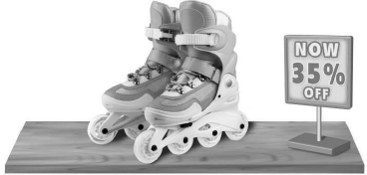

Connections

**14.** Theo does  of his homework. What percent is equal to ?

What percent of his homework does Theo still have to do?

**15. Multiple Choice** In a survey, 75% of 400 parents said they give their children fruit as a snack. How many of the parents surveyed gave that response?

**A.** 150 **B.** 200

**C.** 225 **D.** 300

**19. Multiple Choice** Ike’s Bikes requires 25% of the cost as a down payment for a new mountain bike. What fraction of the cost is this percent?

**F.**  **G.**  **H.**  **J.** 

**20.** Four friends order a square pizza. Marisa says she isn’t very hungry and only wants 10% of the pizza. Tomarr is very hungry and says he will eat 50% of the pizza. Jon says he will eat 35%, and Kwan says she will eat 15%. Is this possible? Explain your reasoning.

