Name\_\_\_\_\_\_\_\_\_\_\_\_\_\_\_\_\_\_\_\_\_\_\_\_\_\_\_\_\_\_\_\_\_\_\_\_\_\_\_\_\_\_\_\_\_\_Date\_\_\_\_\_\_\_\_\_\_\_\_\_\_\_\_\_\_\_\_Period\_\_\_\_\_\_\_

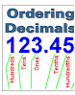

***ACE 2 – Decimal Ops***

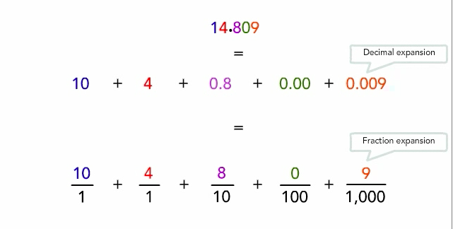

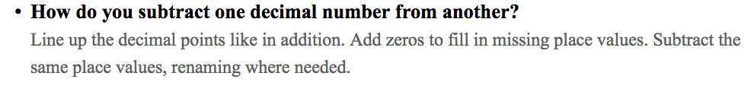

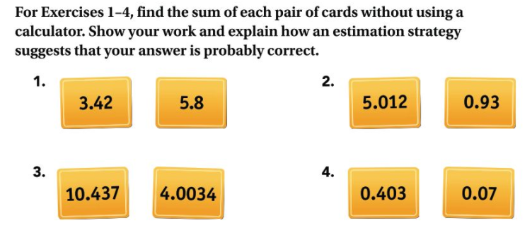

**5.** During the Memorial High School highway clean-up project, Ms. Palkowski cleaned 0.125 of a mile for the teachers’ team and then 0.4 of a mile for the science club. How much did she clean altogether?

**6. Multiple Choice** Which is the correct decimal sum?

**A. B.**



**C. D.**



**7.** Find each sum.

**a. b.** 91.678 + 2.34 + 12.001



**c.**



**8.** Place decimal points in 102 and 19 so that the sum of the two numbers is 1.21.

**9.** Place decimal points in 34, 4, and 417 so that the sum of the three numbers is 7.97.

**For Exercises 10–15, find each difference without using a calculator. Show your work and explain how an estimation strategy suggests that your answer is probably correct.**

**10.** 5.2 – 0.12 **11.** 4.54 – 2.9

**12.** 0.095 – 0.0071 **13.** 2.057 – 1.99

**14.** 10 – 1.068 **15.** 5.63 – 4.05 + 9.2

**16.** Place decimal points in 431 and 205 so that the difference of the two numbers is 16.19.

**17.** Find the value of *n* that make each sentence true. Then write the addition and subtraction fact family for the sentence.

**a.** 22.3 + 31.65 = *n* **b.** 18.7 – 4.24 = *n*

**18.** Find the value of *n* that makes each sentence true. Use fact families to help.

**a.** 2.3 + *n* = 3.42 **b.** *n* – 11.6 = 3.75

**19.** Find the missing numbers.

**a.**  36.03

+ n

45.218

**b.**  n

+ 0.488

13.762

**c.** 0.45 + *n* + 0.4 = 2.62

**d.** 75.4 – 10.801 + *n* = 77.781

Connections

ACE_dots

**For Exercises 21–26, perform each calculation.**

**21.** 5(10 + 7) **22.** 43 • 2 **23.** 10 (42)

**24.  25.**33 **26.** 2(10 – 8) + 8

**For Exercises 34–37, find each sum or difference in fraction form.**

**34. ** **35. **

**36.**  ** 37. **

**40.** Rewrite Exercises 34–37 with decimal numbers and find the results of the operations using the decimal equivalents. Compare your decimal  
answers to the fraction answers.

**Decimal Version:**

34) 35)

36) 37)